Government of Orissa Women & Child Development Department

No.HW-II-A-62/04. /W&CD, Dt.
From:
Shri S.B. Agnihotri, IAS,
Commissioner-cum-Secretary to Govt.
To
The Joint Director,
Institutional Finance & Joint Secretary to Govt.
Finance Department
Sub:- Accessibility of banking facilities to Persons with disabilities and issue of Cheque Books to Visually impaired persons.
Sir,
Section 44, 45 and 46 of the Persons with Disabilities (Equal Opportunities, Protection of Rights and Full Participation) Act, 1995 (PWD Act) stipulate provision of non-discrimination in transport/ built environment and on the road. The Act has made it mandatory on the part of the Government to take necessary steps to provide a barrier-free environment and access to Persons with disabilities.
The Regional Managers/Zonal Managers of all Nationalised Banks in the State were requested vide this Deptt.'s letter No.14288/WCD, dt.25.6.2004 to construct ramps in their Banks located in different parts of the State for easy access of disabled persons to the Banks.
The Deputy Chief Commissioner for PWDs in his letter No.36-1/BF/CCD/
2003/4523 dt.14.7.2004 (copy enclosed) has, emphasized on accessibility of banking facilities to persons with disabilities and issue of Cheque Books to Visually impaired persons A note on this item is sent herewith to be included in the Agenda of the next SLBC meeting.
It is also requested that priority attention may be accorded to this and Regional Managers/Zonal Managers of the Nationalised Banks who are members of the SLBC be intimated to take appropriate action in the matter. Action taken in this regard may be intimated to this Department at an early date.
Yours faithfully,
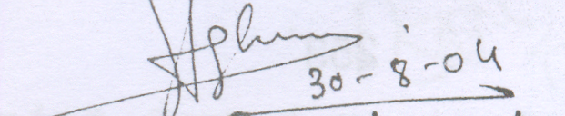 Commissioner-cum-Secretary to Govt.

