•■

Ms Madhur Sarangi, IAS

Fax
Secretary to Government
Women & Child Dev. Department
Orissa
Tel: 402575 (Off..) 402502 (Res.) 406756 / 407 142
No14288/WCD

Date: 25.06.2002
Bhubaneswar- 75100

To
The Regional Managers/Zonal Managers All Nationalised Banks/
Managing Director, State Co-operative Bank Sub: Barrier-free access facilities to disabled persons in important public buildings/places.

Sir
Sections 44, 45 and 46 of the Persons with Disabilities (Equal Opportunities, Protection of Rights and Full Participation) Act, 1995 (PWD Act) stipulate provision of barrier-free access to persons with disabilities in public places/roads and buildings. The Act has made it obligatory on the part of Government to take necessary steps to provide a barrier-free environment and access to persons with disabilities. A copy of the extract of Chapter-VIII of the PwD Act is sent herewith for ready reference.
It would be in the fitness of things if the Banks construct ramps at the entry points of their buildings located in different parts of the State. Providing carrier-free access to the disabled in public buildings has been taken up as an important agenda by the Government. Hence, you are requested to accord prompt attention to this matter and get ramps constructed at the entry point in all the Bank buildings at the earliest.
Action taken in this regard may kindly be intimated to this Department.

Yours faithfully,
I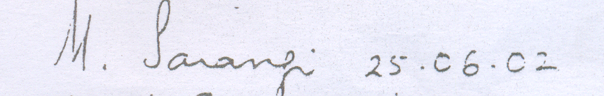

Secretary to Government and Commissioner, Disabilities.

256

