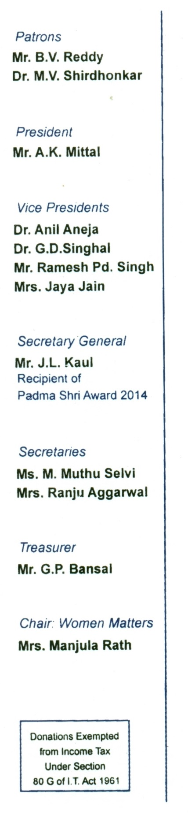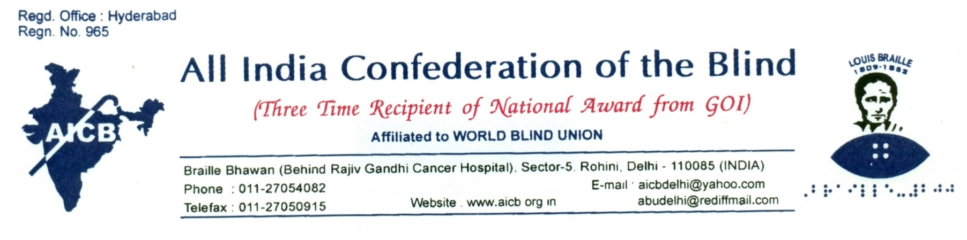

29th May, 2017

To,

The Honorable Sh. Arun Jaitley

Union Minister of Finance,

Government of India,

North Block,

New Delhi- 110001.

**Sub: Representation requesting the waiver of the proposed GST on items to be used by persons with disabilities.**

Sir,

We are a premier self-help national organization of the Blind having 26 affiliates across the country and running more than 20 projects for the empowerment of persons with visual disabilities in various areas. We greatly appreciate the significant steps taken by the Government of India for the empowerment of persons with disabilities, particularly during last three years under the able leadership of our honorable Prime Minister esteemed Narendra Modi Ji, and his team. However, we wish to draw your kind attention towards the fact that a recent decision taken by the GST council on 18th May, 2017 regarding the levying of GST on goods and equipments to be used by persons with disabilities, has the strong potential of undermining and impairing the excellent work done by your Government for the empowerment of such persons.

Sir, as you may be well aware, the GST Council has proposed a levy of 5-18% GST on items for the disabled mentioned in list 32.

Besides, the above GST has been levied specifically as follows:

Braille Typewriters – 18%

Braille Paper – 12%

Braille Watches – 12%

Braillers – 5%

Carriages for disabled – motorised or not – 5%

Cars for physically handicapped persons – 18%

It is pertinent to note that all the above items including but not limited to the ones mentioned in list 32 notified on 17th March, 2012 vide notification no. 12/2012, have been exempt from all taxes and duties earlier. Therefore, imposing any GST/ duty on these items now will be detrimental to the interest and empowerment of persons with disabilities. For instance, the braille books for blind children and the wheelchairs for the orthopedically handicapped will now become more expensive creating hurdles in their education and other spheres of life. As you would kindly appreciate, persons with disabilities face a number of serious hardships in their day to day functioning and the goods and equipments mentioned in list 32 as also other assistive devices are critical materials for such persons to live an empowered and dignified life. Also, the recent Rights of Persons with Disabilities Act, 2016, which has come into force from 19th April, 2017, recognizes the principle of 'reasonable accommodation' under section 3.5 of this Act. Further, sections 40-46 of the said Act enjoin upon the appropriate government to ensure multiple dimensions of accessibility for persons with disabilities towards which the above mentioned goods and equipments as also other assistive devices are essential and integral means.

It may also be mentioned here that most persons with disabilities come from economically weaker sections of society and affording the other goods and equipments as also other assistive devices becomes extremely difficult for them. Levying of GST on these goods and equipments will make such materials further inaccessible to such persons creating serious difficulties in their day to day functioning particularly in the areas of education and employment which are central to a dignified life of persons with disabilities.

Further, it may be noted that most of the work for the empowerment of persons with disabilities in India, is being done by the voluntary/ NGO sectors. In the absence of adequate support from Government, this sector has to rely upon community resources which are rather hard to obtain. Lack of resources has been a constant challenge for the NGO sector to provide desired materials and equipments such as braille books and assistive technology to persons with disabilities. The work was made a bit easier by the exemption of various taxes and duties on the above items which are critical for providing support to persons with disabilities.

In view of the above, the decision of the GST Council to levy GST ranging from 5-18% on items which are specifically used for and by persons with disabilities will have a serious negative impact on the efforts of the voluntary sector as well to provide support to such persons as also on the capacity of the individuals to acquire such items.

Therefore, in the interest of more than 5% disabled population of the country, we respectfully request you to kindly reconsider and reverse the decision taken by the GST council on 18th May, 2017 to levy GST ranging from 5-18% on various items for the disabled mentioned in list 32 as also on other items, goods, equipments, and other technology. While GST as such is a praiseworthy initiative, it will not be acceptable if it aims to withdraw those benefits and exemptions which have earlier been granted to persons with disabilities because such withdrawals go against the letter and spirit of creating an equitable society through affirmative action. Further, any levying of GST on the items in reference will be against the letter and spirit of the Rights of Persons with Disabilities Act, 2016, which your esteemed Government has worked so hard to bring forth and implement.

We respectfully request you to immediately withdraw the decision of the GST Council taken on 18.05.2017 to impose 5-18% GST on items in reference to be used by persons with disabilities. We further request to you to kindly grant an opportunity for a meeting to a small delegation of our organization so that we can state our concern in person to you. Hoping for an immediate positive action.

Sincerely Yours,



J. L. Kaul

Secretary General

Copy to: All affiliated organizations and activists with the request to take up the matter with the Finance Minister on the basis of representation being sent by AICB.