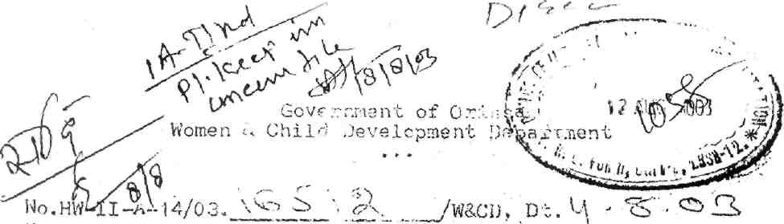
From:
Shri P.Singh,
Deputy Secretary to Govt.
To
All Chief District Medical Officers
C.H.O. Capital Hospital, Unit-VI, Bhubaneswar
Superintendents of Medical Colleges & Hospitals
Sub':- Issue of Disability Certificates to disabled persons.
Madam/Sir,
I am directed to say that instructions have already been .issued in this Deptt's letter-No. 14920/WCD dt.17.11.2001, No.21246/
dt. 1.10.2002 and No. 23913/ CD. dt. 15. 11.2008 for issuance of Disability Certificates to eligible disabled persons by the Medical boards constituted for the purpose.
- It has come to the notice of the Govt. that disabled persons are finding it difficult to obtain disability certificate it some quarters due, to non-production of residential certificates before the Medical Boards. This, goes against the provisions of the PwD Act.
- You are aware that the Act is applicable to the whole of the country except the State of Jammu and Kashmir. Therefore, the Medical Boards should not insist on production of residential certificates for issue of disability certificates.
4. I would, therefore request that Disability Certificates
may be issued to eligible disabled persons who possess any one of
documents like BPL Card, Electricity Card, Ration Card, Voter Card,
Pass port, Birth Certificate etc. which establishes their claim as
Indian Citizens.
Yours faithfully,

Deputy Secretary to Govt.
Memo No.16513/w&CD. Dt.4.8.03
Copy forwarded to the Health & F.W.Deptt./Director of Health Services, Orissa, Bhubaneswar/All Collectors/All D.S.W.Os for information and necessary action.

Deputy Secretary to Govt.
24

