S tj

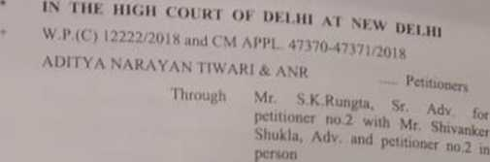

UNION OF INDIA\* ANB

lliroughMrVivck Goyal, CGSC with Mr

Pawan Pathak. Adw for R-l MrJagat Arora and Mr. Rajat Arora.Adv for R-2

CORAM:

HON'BLE MR. JUSTICE SLKESH KUMAR KAIT L>.1U> E R

%

15.11.2018

Pursuant to order dated 14.11.2018. counsel for the respondent no. 2 has made appearance and submits that the representation has been considered by the Department of Empowerment of Persons with Disabilities. Ministry of Social Justice & Empowerment and accordingly the Department has clarified to IBPS. Respondent no.2 herein, that the guidelines dated 29.08.2018 are applicable for all the examinations for recruitment for which advertisement is notified on or after 29.08.2018. The guidelines dated 26.02.2013 arc applicable for die examinations for which action has been initiated prior to

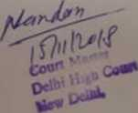

” 082018 'h,:PrCSCn'CaK ,h' adVCn'Semcmw“Prioru.

Since the respondent no.2 has taken the decision that they shall not implement the guidelines dated 29.08.2018 in the examination of Probationary Officers and Management Training to be conducted on 18 11.2018, the prayer for the said purpose is satisfied, at this stage Consequently, the necessary changes shall be carried out on the portal of respondent no.2 for the examination which is to be held on 18.11.2018.

For the remaining issues raised in this case, counsel for the respondent no. 1 seeks time to file counter affidavit

Let the needful be done within four weeks from today. Rejoinder thereto, if any.to be filed within two weeks thereafter

I hereby made clear that no examination of any of the Department shall be conducted without complying obligations under Clause V of guidelines dated 29.08.2018 issued by respondent no.l. Respondent no. I shall communicate this order to all the concerned Departments for compliance.

Rcnotify on 09.01.2019.

Order dasti under signatures of Court Master



SlIRESH KUMAR KAIT.J

NOVEMBER 15. 2018

*si>*

