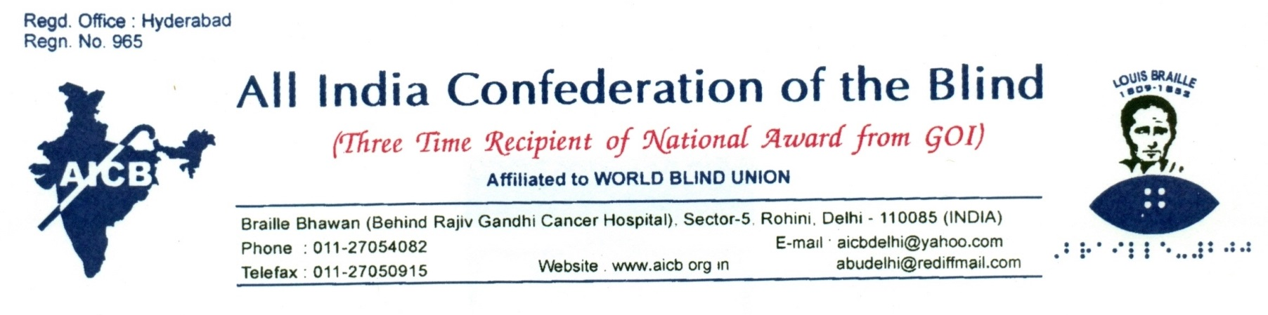
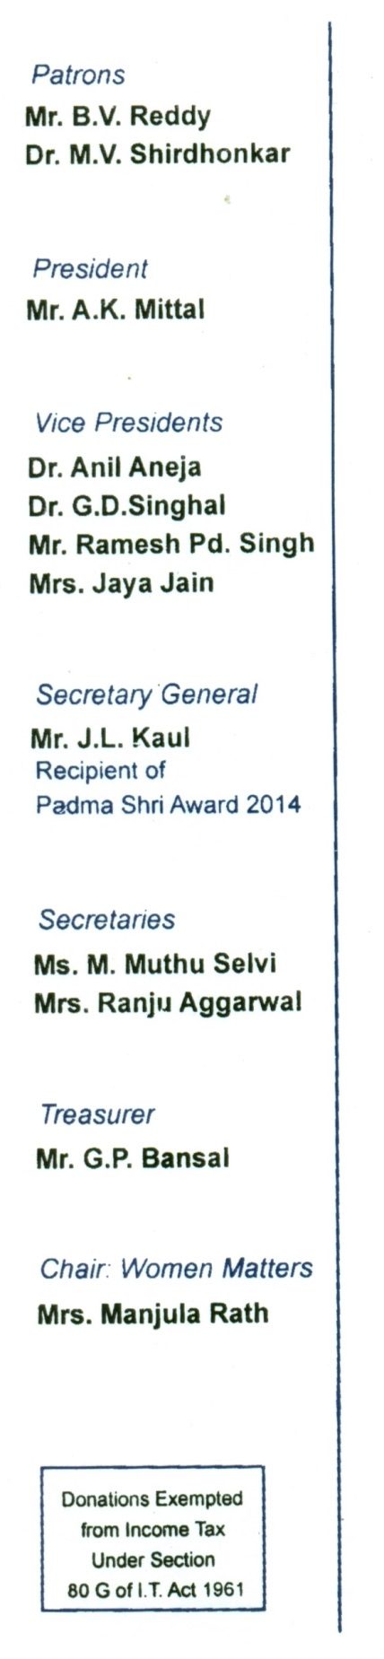
Press Release

New Delhi Dated: 18.12.2018

United Nations Declares January 4 as “World Braille Day”

The United Nations General Assembly has passed a Resolution on 17th December, 2018 designating Louis Braille’s Birth Anniversary, January 4, as “World Braille Day”. The purpose of the Resolution is to raise awareness about the importance of Braille and to promote its use for the benefit of visually impaired persons worldwide.

The movement for securing UN recognition for the Day was spearheaded by the World Blind Union (WBU), the global organization of the blind. It was at its fifth General Assembly held in Melbourne, Australia in 2000, that WBU had itself officially declared 4th January as World Braille Day and called upon the UN to do likewise. The efforts of WBU have now been crowned with success.

In his message from the UN Head Quarters in New York City, the WBU President, Dr. Fredric K. Schroeder (from U.S.) has observed: “this is wonderful achievement especially because Braille is the means of literacy for blind people. Literacy is the foundation of education and the foundation of full integration for the visually impaired”.

Secretary General of WBU, Mr. A.K. Mittal (from India) has commented: “this is great news. Braille will remain the doyen of systems for giving to the visually impaired access to knowledge which is the main source of empowerment.”

We sincerely hope that this declaration by the UN will further encourage our Government’s efforts to provide meaningful education in Braille for blind children and enable them to get much easier and faster access to reading material in Braille and necessary assistive devices.

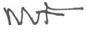
(J.L. KAUL)
SECRETARY GENERAL

