GOVERNMENT OF INDIA
MINISTRY OF RAILWAYS
(RAILWAY BOARD)

No. E(NG)ll/2006/RC-2/13 New Delhi, dated 27 .4.2012

The General Manager(P),
All Zonal Railways/Pus,
Chairmen/RRBs.

Subject: Guidelines for providing concessions/facilities including scribes
to persons with disabilities while conducting examination for
their recruitment from open market against 3% quota-
regarding.
****

Attention is invited to Para 2(ii)(c) of this Ministry's letter No. E(NG)ll/2006/RC-2/13 dated 17.9.2007 on the above subject. The matter has been reviewed by the Board and it has accordingly been decided that the clause of 60% as mentioned in Para 2(ii)(c) of the letter ibid is deleted and may now be read as under:
"the scribe can be of any academic discipline if the recruitment is for general post. If the recruitment is for a specialized post, he/she should be from a discipline different from that of a candidate."

Please acknowledge receipt.

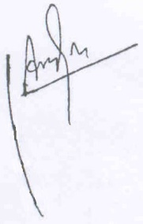

(RAVI SHEKHAR)
Dy. Director Estt. (N)ll
Railway Board.

