F.No.11013/9/2014-Estt.A.III
  
Government of India
  
Ministry of Personnel, Public Grievances and Pensions
  
(Department of Personnel and Training)

North Block, New Delhi Dated the 19th May, 2020

**OFFICE MEMORANDUM**

**Subject: Preventive measures to be taken to contain the spread of Novel Coronavirus (COVID-19) — Attendance regarding.**

In continuation of this Ministry's O.M. of even number dated the 18th May, 2020, it has been decided that the Government servants who have underlying conditions (co-morbidities) and were undergoing treatment for these ailments before lockdown, may, as far as possible, be exempted from roster duty upon production of medical prescription from treating physician under CGHS/CS(MA) Rules, as applicable. Similarly, Persons with Disabilities and Pregnant Women may also not be included in the roster to be prepared.

(Umesh Kumar Bh tia) Deputy Secretary to the Govt. of India

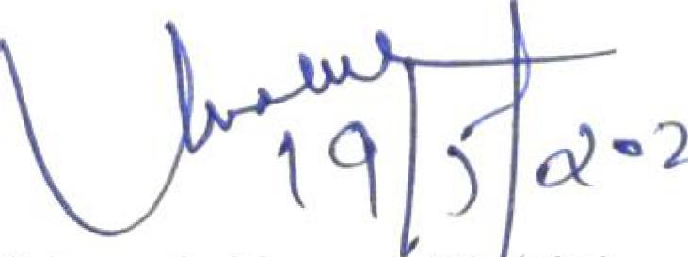

° 2

To

1. All the Ministries/Departments, Government of India
2. PMO/Cabinet Secretariat
3. PS to Hon'ble MOS(PP)
4. PSO to Secretary(Personnel)

For Information

1. Sr. Tech. Dir., NIC, DoP&T